Test cases
- Test Case 1 — Simple Path. An open 6×8 grid with a small cluster of obstacles between the start and goal. Path found: yes. Total path cost: 12. Nodes explored: 41. Execution time: ~0.00008s. The path cost of 12 exactly matches the Manhattan distance between S and G, meaning the optimal path never needed to detour around any obstacle — the obstacles present did not block the shortest possible route.

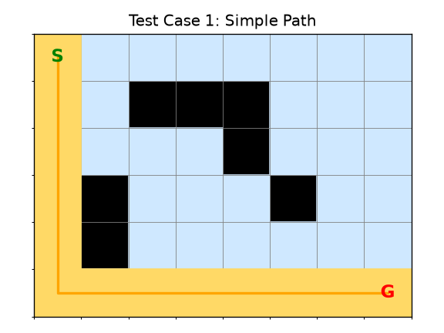

- Test Case 2 — Multiple Possible Paths. A largely open grid with a single vertical wall of obstacles that can be gone around either above or below. Path found: yes. Total path cost: 11. Nodes explored: 39. Since the grid is open on both sides of the wall, several equal-cost routes exist; A* returns whichever one its expansion order reaches first, not necessarily a “preferred” one, since all equal-cost paths are equally optimal.

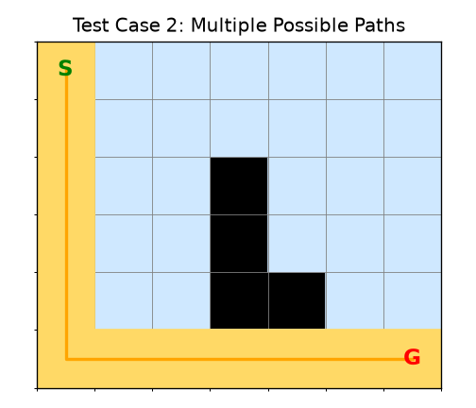

- Test Case 3 — Narrow Passage. A maze-like layout with a single winding corridor connecting S and G. Path found: yes. Total path cost: 20. Nodes explored: only 21 — very close to the path length itself. This is a direct illustration of how A* behaves when there is little to no branching: because the corridor offers almost no alternative routes to consider, the search barely explores any cell that isn’t part of the eventual path.

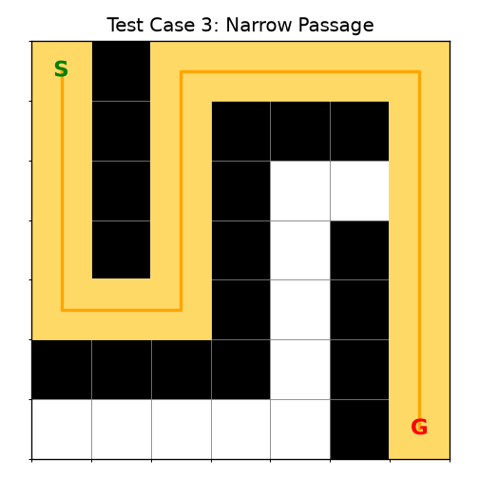

- Test Case 4 — Different Obstacle Arrangement. A grid with obstacles arranged in a different, more scattered pattern. Path found: yes. Total path cost: 12. Nodes explored: 16 — even fewer than Test Case 1, despite a similar path cost, because the heuristic guided the search almost directly toward the goal with very little wasted exploration in this particular layout.

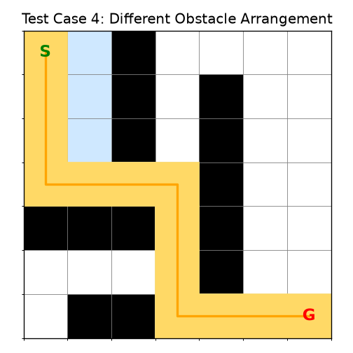

- Test Case 5 — No Valid Path. The start cell is completely walled in by obstacles on all sides. Path found: no. Nodes explored: 1 (only the start cell itself, since it has zero legal neighbour to expand into). This confirms the algorithm correctly detects and reports an unreachable goal rather than looping indefinitely or crashing, terminating as soon as the open list is exhausted

